Guide to Run

Using Visual Studio >> Open Folder the Handymantsatic

Then

Click on this and click on Terminal

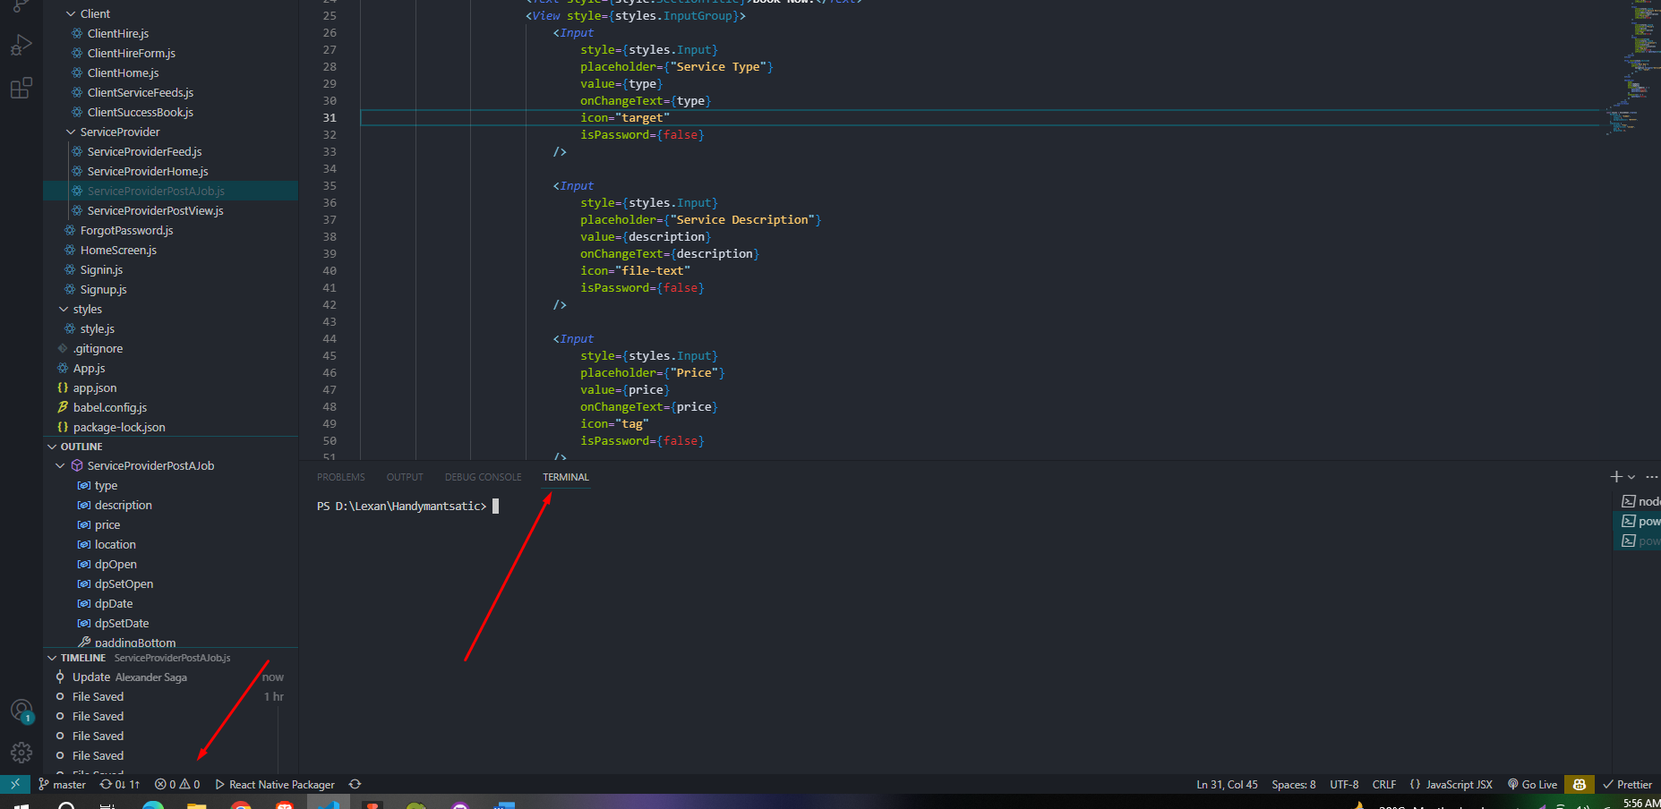  
  
Run this command > npx expo start

Download Expo App and Scan this QR Code  
